Instructions to use the API:

1. Go to the link mention in the Host file link.txt.
2. This link will open a swagger documentation for the API.
3. Anyone can play the game from the swagger documentation API only.

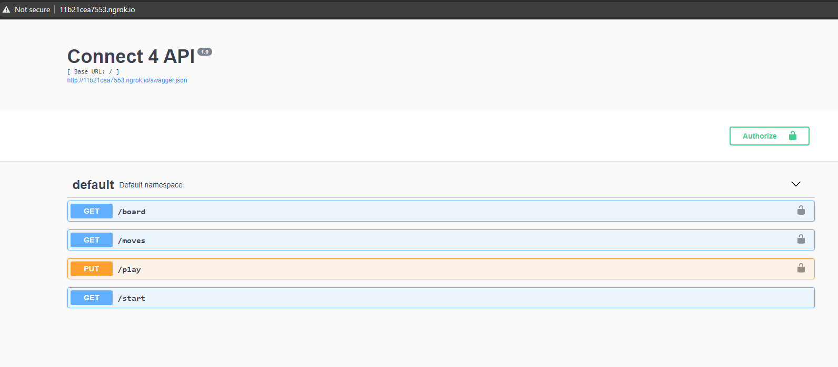

1. API have 4 endpoints named as follows :
   1. /start -> To start the game and get the token for playing the game.
   2. /play -> To send request with a column number b/w (0-6).
   3. /moves -> To fetch all moves made in a game.
   4. /board -> To fetch the status of game board.
2. First user must send request on endpoint /start. As shown in the fig. In response user will get a message “Ready” and a token to play the game also an empty board will be created for the players.

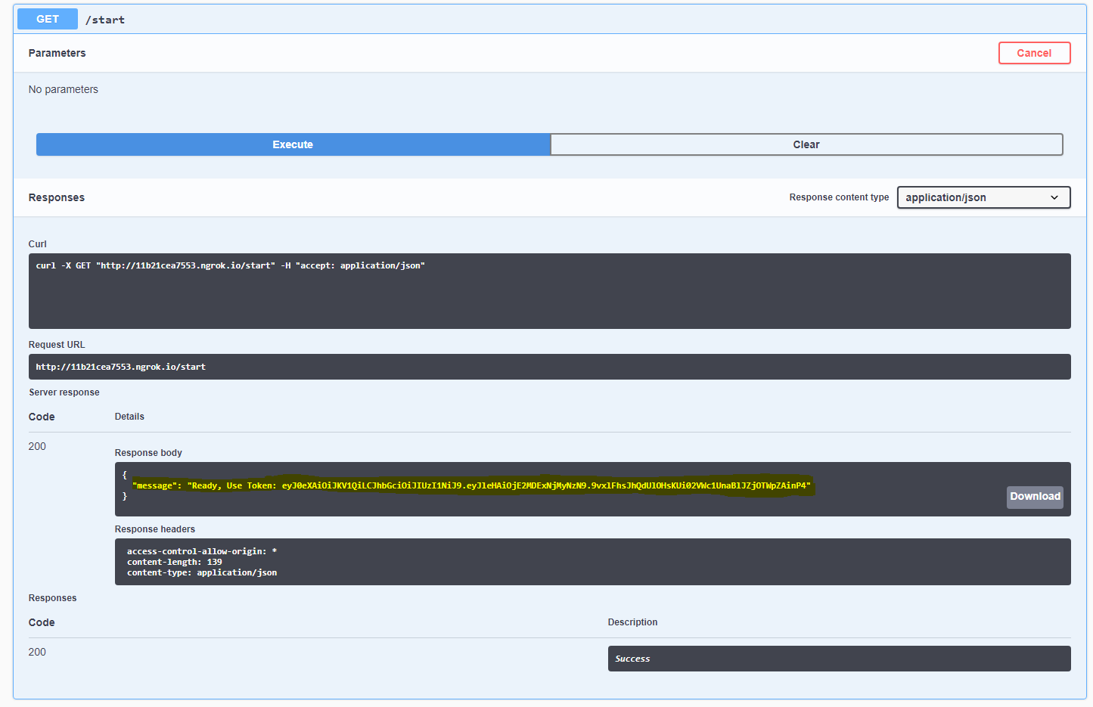

1. Then user must copy the token from the previous response and authorize the application to use other endpoints.
   1. For authorizing click on the Authorize green button on top right corner and enter your token and click authorize.
   2. 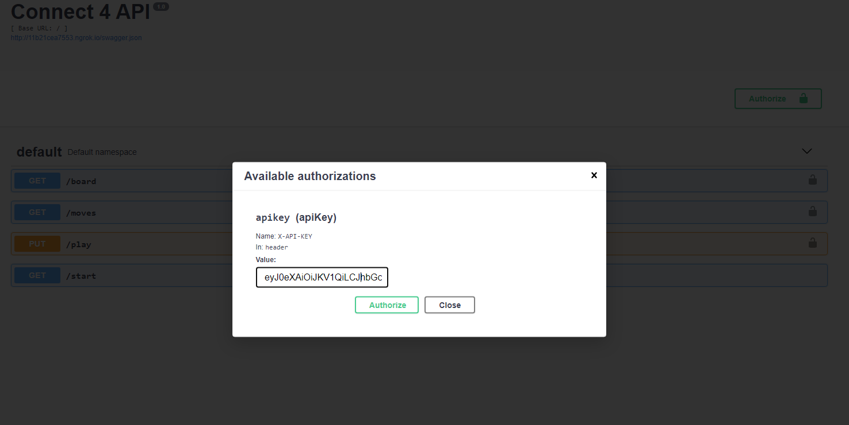
2. After you hit the authorize button all the other endpoint will be attached to the token.
3. Now you can start sending requests from the /play endpoint with column included in the form data. You can do that directly from the swagger docs. As show in the fig below.

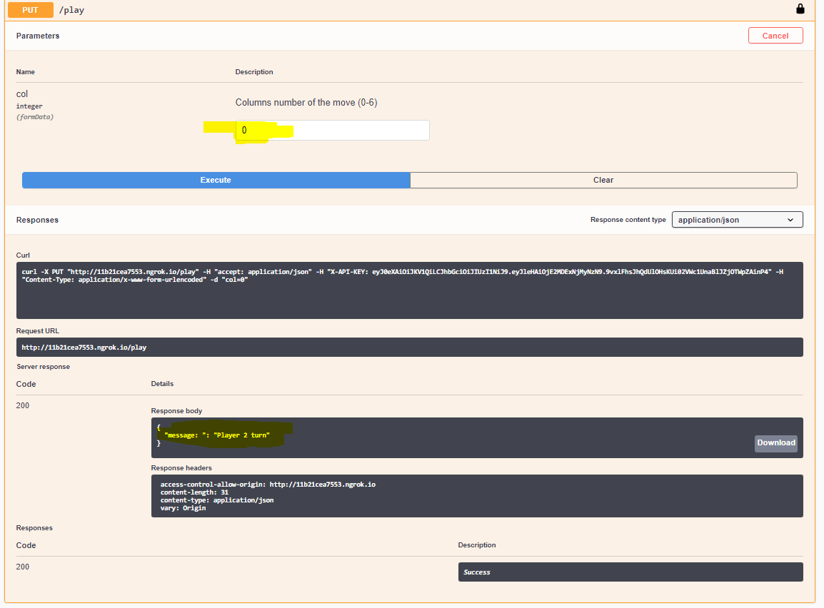

1. Above request with column number 0 means, player one have dropped its coin to the lower most possible place of column 0.
2. First /play request will always for the player 1. After sending the first request you will get a response “Player 2 turn”.
3. Now second player can send the /play request with a column number to drop its coin.
4. Finally after sending /play requests, when any player will able to connect its 4 coins horizontally, vertically , +ve diagonally or -ve diagonally, The /play end point will give response like “Player 1 Wins” or “Player 2 Wins”.

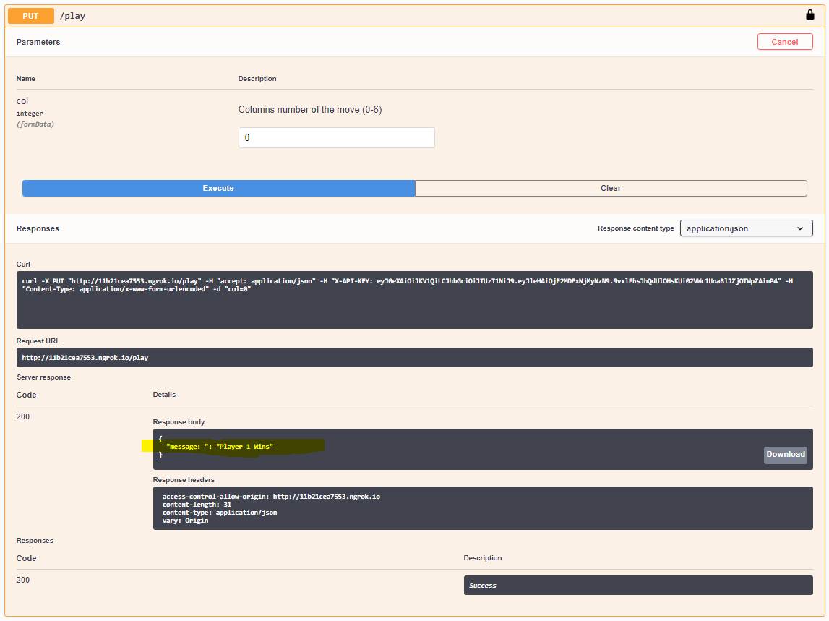

1. With /board endpoint player can see the status of the after dropping a coin.

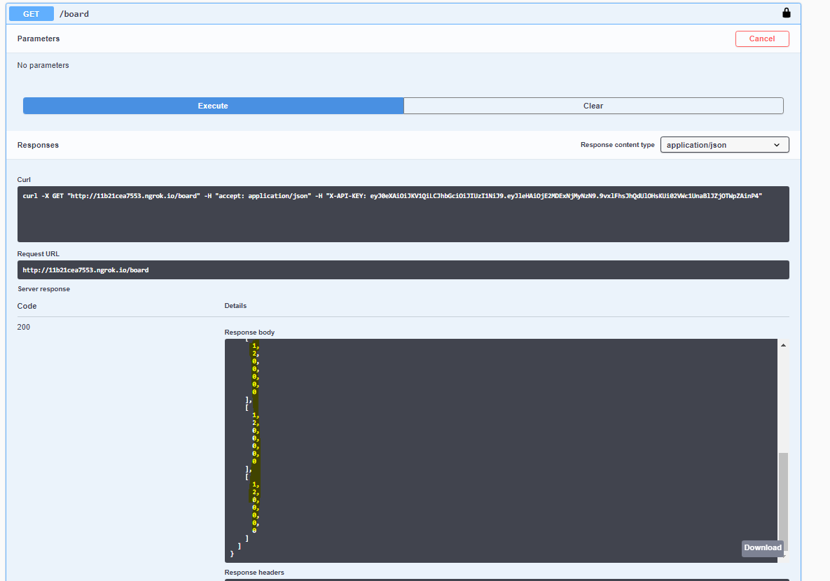

* 1. In the above response ‘1’ is the coins of player one and ‘2’ is the coins of player two.

1. Players can also fetch all the moves made with the game board by sending the /moves request.
   1. In response users will get column, row, and player who made that move.

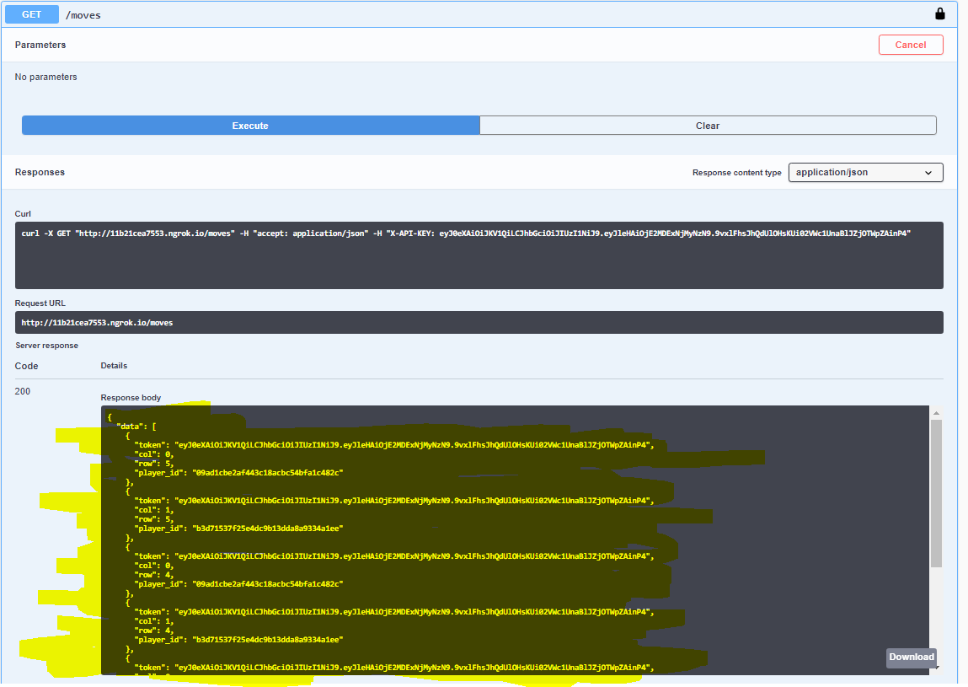

Please if you have any trouble accessing the API url or any other endpoint. You can contact me on [vishalyo990@gmail.com](mailto:vishalyo990@gmail.com) or 6352282184.

**Note: The app is currently locally hosted with the docker compose as docker containers and port is forwarded via ngrok. Due to the lack of cloud resources I had.**